filter()
filter method of model manager read data from database table based on condition. It returns queryset which contain one or more than one record based on given condition.

Syntax: model-name.objects.filter(condition)

>>> from app1.models import Student
>>> qs1=Student.objects.all()
>>> print(qs1)
<QuerySet [<Student: Student object (1)>, <Student: Student object (2)>, <Student: Student object (3)>, <Student: Student object (4)>, <Student: Student object (5)>]>
>>> print(qs1.query)
SELECT `app1_student`.`rollno`, `app1_student`.`name`, `app1_student`.`course`, `app1_student`.`fee` FROM `app1_student`
>>> qs2=Student.objects.filter(course='c++')
>>> print(qs2)
<QuerySet [<Student: Student object (3)>, <Student: Student object (4)>]>
>>> print(qs2.query)
SELECT `app1_student`.`rollno`, `app1_student`.`name`, `app1_student`.`course`, `app1_student`.`fee` FROM `app1_student` WHERE `app1_student`.`course` = c++
>>> for stud in qs2:
... print(stud.rollno,stud.name,stud.course,stud.fee)
...
3 kishore c++ 1000.0
4 ramesh c++ 1500.0
>>> qs3=Student.objects.filter(course='mysql')
>>> print(qs3)
<QuerySet []>
>>> qs3.count()
0
>>> qs4=Student.objects.filter(course='python')
>>> print(qs4)
<QuerySet [<Student: Student object (1)>]>
>>> qs4.count()
1
>>> for stud in qs4:
... print(stud.rollno,stud.name,stud.course,stud.fee)
...
1 naresh python 3000.0
>>>

count() method queryset return the total number records fetched from database table (OR) count of records.

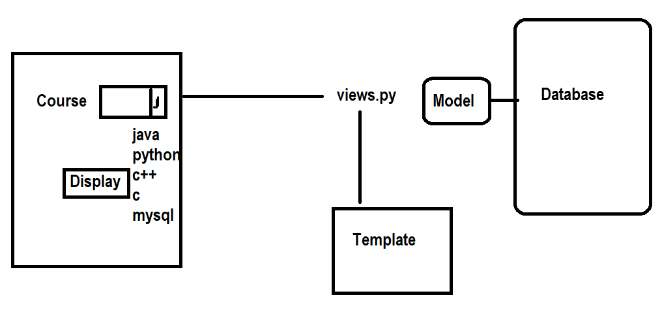
Views.py
def coursehome(request):
response=render(request,"coursetemp.html")
return response
def courseview(request):
c=request.GET.get('course')
qs=Student.objects.filter(course=c)
c=qs.count()
if c==0:
response=render(request,"coursetemp.html",context={'msg':'No Student match with Course'})
else:
response=render(request,"coursetemp.html",context={'qs':qs})
return response

coursetemp.html

<!DOCTYPE html>
<html lang="en">
<head>
<meta charset="UTF-8">
<meta name="viewport" content="width=device-width, initial-scale=1.0">
<title>Document</title>
</head>
<body>
<form action="/courseview" method="get">
<table border="2" width="100%">
<tr>
<td>Course</td>
<td><select name="course">
<option value="java">JAVA</option>
<option value="python">PYTHON</option>
<option value="c++">C++</option>
<option value="c">C</option>
<option value="mysql">MySQL</option>
</select>
</td>
</tr>
<tr>
<td><input type="submit"></td>
<td><input type="reset"></td>
</tr>
</table>
</form>
<table border="2" width="100%">
{%for stud in qs%}
<tr>
<td>{{stud.rollno}}</td>
<td>{{stud.name}}</td>
<td>{{stud.course}}</td>
<td>{{stud.fee}}</td>
</tr>
{%endfor%}
</table>
<h2>{{msg}}</h2>
</body>
</html>

Urls.py
path('coursehome/',coursehome),
path('courseview/',courseview),

and operation

>>> qs6=Student.objects.filter(name='kishore',course='c++')
>>> print(qs6.query)
SELECT `app1_student`.`rollno`, `app1_student`.`name`, `app1_student`.`course`, `app1_student`.`fee` FROM `app1_student` WHERE (`app1_student`.`course` = c++ AND `app1_student`.`name` = kishore)
>>> for stud in qs6:
... print(stud.rollno,stud.name,stud.course,stud.fee)
...
3 kishore c++ 1000.0
>>>

Queryset Field Lookups (Relational Comparisons)
When querying models, Django uses "lookups" that function like relational operators (e.g., =, >, <) in SQL. These are appended to field names using a double underscore (__):

- __exact: Equivalent to = (Equality).
- __gt / __gte: Greater than / Greater than or equal to.
- __lt / __lte: Less than / Less than or equal to.
- __in: Checks if a value is within a given list.
- __isnull: Checks if a field is NULL in the database.

>>> qs7=Student.objects.filter(fee__gt=1000)
>>> print(qs7)
<QuerySet [<Student: Student object (1)>, <Student: Student object (2)>, <Student: Student object (4)>]>
>>> for s in qs7:
... print(s.rollno,s.name,s.course,s.fee)
...
1 naresh python 3000.0
2 suresh java 2000.0
4 ramesh c++ 1500.0
>>>
>>> qs8=Student.objects.filter(fee__gt=1000,fee__lte=2000)
>>> for stud in qs8:
... print(stud.rollno,stud.name,stud.course,stud.fee)
...
2 suresh java 2000.0
4 ramesh c++ 1500.0
>>>
>>> qs9=Student.objects.filter(course__in=['c++','python'])
>>> for stud in qs9:
... print(stud.rollno,stud.name,stud.course,stud.fee)
...
1 naresh python 3000.0
3 kishore c++ 1000.0
4 ramesh c++ 1500.0
>>> print(qs9.query)
SELECT `app1_student`.`rollno`, `app1_student`.`name`, `app1_student`.`course`, `app1_student`.`fee` FROM `app1_student` WHERE `app1_student`.`course` IN (c++, python)
>>>

Views.py
def coursehome(request):
response=render(request,"coursetemp.html")
return response
def courseview(request):
c=request.GET.getlist('course')
qs=Student.objects.filter(course__in=c)
c=qs.count()
if c==0:
response=render(request,"coursetemp.html",context={'msg':'No Student match with Course'})
else:
response=render(request,"coursetemp.html",context={'qs':qs})
return response

coursetemp.html

<!DOCTYPE html>
<html lang="en">
<head>
<meta charset="UTF-8">
<meta name="viewport" content="width=device-width, initial-scale=1.0">
<title>Document</title>
</head>
<body>
<form action="/courseview" method="get">
<table border="2" width="100%">
<tr>
<td>Course</td>
<td><select name="course" multiple>
<option value="java">JAVA</option>
<option value="python">PYTHON</option>
<option value="c++">C++</option>
<option value="c">C</option>
<option value="mysql">MySQL</option>
</select>
</td>
</tr>
<tr>
<td><input type="submit"></td>
<td><input type="reset"></td>
</tr>
</table>
</form>
<table border="2" width="100%">
{%for stud in qs%}
<tr>
<td>{{stud.rollno}}</td>
<td>{{stud.name}}</td>
<td>{{stud.course}}</td>
<td>{{stud.fee}}</td>
</tr>
{%endfor%}
</table>
<h2>{{msg}}</h2>
</body>
</html>

